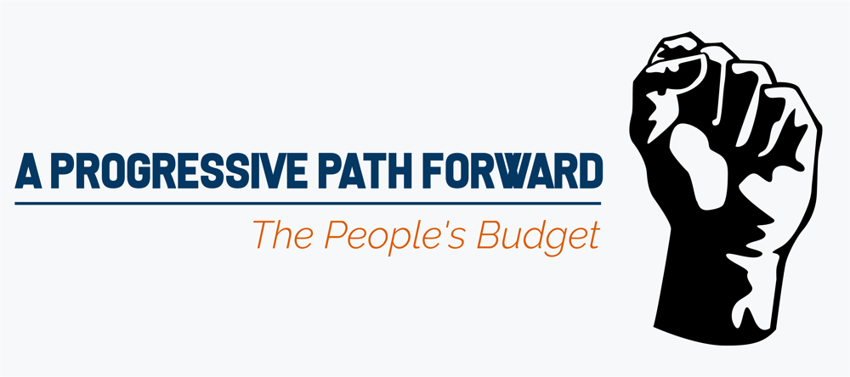

Social Media Guide

Hashtag:

#PeoplesBudget

Tweet at @USProgressives
@repmarkpocan
@RepRaulGrijalva

GOP’s Budget

The @USProgressives are taking the lead in Congress and investing in real solutions for all Americans by releasing their annual #PeoplesBudget.
The @USProgressives are releasing their annual #PeoplesBudget and offering real solutions to the most pressing issues facing our country.
Once again, the @HouseGOP’s budget fails to create growth for the middle-class. The @USProgressives #PeoplesBudget tackles the most important issues facing working families and creates a more prosperous future for all Americans. [LINK to budget]

Tell @SpeakerRyan you want a budget to help all Americans, not just those at the top. Support the #PeoplesBudget [LINK to budget]

Tell @SpeakerRyan that it’s time to help ALL Americans—not just wealthy Republican donors. It’s time to support the #PeoplesBudget

General:

The #PeoplesBudget builds an economy that creates good paying jobs & strengthens the middle class: [LINK to budget]

The @USProgressives are building an economy that works for all Americans, not just the top 1%. Click here to learn more about the #PeoplesBudget: [LINK to budget]

The #PeoplesBudget gives Americans the opportunity to succeed and invests in a future that is prosperous for all – not just the wealthiest.
[LINK to budget]

The #PeoplesBudget reverses Trump’s harmful cuts and fixes a system that for far too long has only benefited those at the top. [LINK to budget]

The @USProgressives #PeoplesBudget puts political and economic power back into the hands of the people and creates a more prosperous future for all Americans.
[LINK to budget]

Infrastructure:

The #PeoplesBudget provides a $2 trillion investment to fix roads & bridges and rebuild our crumbling infrastructure.

The #PeoplesBudget closes loopholes that allow companies to shift jobs and hurt the American worker. Click here to learn how the @USProgressives are standing up for you: [LINK to budget]

The #PeoplesBudget invests $100 billion in broadband technology so that all communities have access to high-speed reliable internet.

Taxes:

The #PeoplesBudget stops companies from dodging U.S. taxes and ensures they pay their fair share. Click here to learn how the @USProgressives are standing up for working families: [LINK to budget]
The #PeoplesBudget closes loopholes companies and CEOs have exploited to evade paying their fair share and creates a tax system that works for all Americans. Click here to learn how the @USProgressives are standing up for working families: [LINK to budget]

The #PeoplesBudget creates a fair tax system that puts working families first by expanding the EITC and Child Tax Credit.

Health Care:

The #PeoplesBudget expands access to mental health care and treatments for opioid addiction in local communities across America. Click here to learn how the @USProgressives are making sure health care remains affordable and accessible: [LINK to budget]
The #PeoplesBudget fights back against the high cost of prescription drugs and makes sure reliable care is affordable and accessible. Click here to learn how the @USProgressives are fighting for you: [LINK to budget]

The #PeoplesBudget would allow states to transition to a single payer health care system to reduce costs and increase coverage. Click here to learn how the @USProgressives are standing up for healthcare for all: [LINK to budget]

Education:
The @USProgressives are using the #PeoplesBudget to overhaul the broken student loan system and work towards college free of debt. Click here to learn how the @USProgressives are investing in real solutions that will help students across the country: [LINK to budget]
The #PeoplesBudget fully funds Early Head Start and provides $1 trillion for childcare for all.

Criminal Justice & Fair Elections:
The #PeoplesBudget fights back against voter restriction laws that undermine our democracy by strengthening DOJ voter protection programs across the country. Click here to learn how the @USProgressives are committed to protecting the right to vote: [LINK to budget]

We need a criminal justice system that works for all Americans. The #PeoplesBudget supports sensible criminal justice reforms by allocating substantial funding to community-oriented policing.
The #PeoplesBudget increases funding to update and secure our voting systems to protect our elections from any foreign interference.

Immigration and Refugees:

The #PeoplesBudget endorses comprehensive immigration reform and opposes immigration bans on Muslims and refugees. We need an immigration policy that’s humane, fair and consistent with our American values. Click here to learn more [LINK to budget]

The #PeoplesBudget prohibits funding for @realDonaldTrump’s divisive border wall. The @USProgressives forcefully reject President Trump’s hateful and dangerous rhetoric.

The #PeoplesBudget will push back against any immigration policy that separates families or prevents asylum seekers from entering the country and being treated fairly. Click here to learn more [LINK to budget]

Jobs and Wages:

The #PeoplesBudget creates millions of good paying jobs that will spark wage growth for hardworking families. Click here to learn how the @USProgressives are committed standing up for working Americans [LINK to budget]

The @USProgressives understand that hardworking families are struggling to get ahead. The #PeoplesBudget gives workers a raise and increases opportunity for families across the country.

The #PeoplesBudget invests in families and provides hard-working Americans with the raise they deserve: [Link to Budget]

The @USProgressives are fighting for a seat at the table for America’s workers. The #PeoplesBudget ensures a fair wage, good benefits, and collective bargaining in the workplace.

Pathway out of Poverty:

The #PeoplesBudget strengthens our social programs by restoring the GOP’s cuts to #SNAP & expanding emergency unemployment compensation. Click here to learn more about how the @USProgressives are standing up for you [LINK to budget]

The #PeoplesBudget will protect and strengthen the social programs our most vulnerable communities need to survive. The @USProgressives will continue to make sure everyone is given a fair shot to get ahead.

The #PeoplesBudget helps provide a pathway out of poverty for low-income Americans and restores economic security for the working class. Click here to learn more about how the @USProgressives are standing up for you [LINK to budget]

Women’s Rights:

The #PeoplesBudget supports women’s #reprorights by increasing Title X funding and lifting Hyde Amendment restrictions #BeBoldEndHyde

The #PeoplesBudget supports women’s economic empowerment by addressing pay inequality and supporting paid leave policies. Learn more about how the @USProgressives are committed to ending pay inequality [LINK to budget]

The #PeoplesBudget pushes back against the harmful policies of @realDonaldTrump’s administration by ensuring women have quality health care, earn equal pay, and have paid leave benefits.

Child Care for All:

The #PeoplesBudget makes sure parents can access quality child care they can rely on. @USProgressives are investing $1 trillion for #childcare for all.

The #PeoplesBudget ensures that families will not have to pay more than 7 percent of their income for child care. Providing working families with the support they need to succeed is a priority for the @USProgressives.

Veterans:

The #PeoplesBudget increases funding for veteran supportive housing, which will work to eliminate veteran homelessness and offer them the support they need. Click here to learn more: [Link to Budget]

Defense:

The #PeoplesBudget increases funding for diplomacy and ends the policy of funding endless wars. Click here to learn more: [Link to Budget]

Environment:
The #PeoplesBudget makes a substantial investment in green technology – instead of providing incentives and loopholes for the oil and gas industries. Click here to learn more about how @USProgressives are committed to protecting our environment. [Link to Budget]

The #PeoplesBudget takes bold action to fight climate change and invests in a clean-energy economy that supports green jobs with good wages. Click here to learn more about how the @USProgressives are committed to protecting our environment. [Link to Budget]

The Trump Administration is threatening our environment and rolling back regulations that will imperil public health for years to come. Click here to learn more about how the @USProgressives are committed to protecting our environment [Link to Budget]

The @USProgressives are leading the charge to push back against the harmful environmental policies from @realDonaldTrump. Instead of giving in to the oil and gas industry, the #PeoplesBudget invests real resources to combat climate change.
Tweets with links to EPI report:

The #PeoplesBudget would finance public investments, create jobs, and strengthen economic security. http://on.epi.org/2qokLa5

The #PeoplesBudget is a progressive roadmap to the resistance! http://on.epi.org/2qokLa5

Investing in infrastructure, child care, and green energy will create jobs and accelerate productivity growth. #PeoplesBudget http://on.epi.org/2qokLa5

Working families deserve a budget that works for them. #PeoplesBudget http://on.epi.org/2qokLa5

The #PeoplesBudget would grow GDP by 2% and create 2.4 million jobs. http://on.epi.org/2qokLa5

If passed, the #PeoplesBudget would reduce public debt by $4 trillion by 2027. http://on.epi.org/2qokLa5

Facebook:

- The Progressive Caucus Budget helps lift families out of poverty, gives students the opportunity to get a debt-free college education, funds universal childcare, invests in rebuilding our crumbling roads and bridges, and creates millions of good-paying jobs. This is what a People’s Budget looks like. [LINK TO NEW BUDGET]

- How would the #‎PeoplesBudget‬‬‬‬‬‬‬‬ help you? With any of below text:

  - By protecting clean air, clean water, and our planet. The People’s Budget ends subsidies to fossil fuel companies, places a tax on carbon pollution, increases access to heating assistance programs for families, and invests in renewable energy and green manufacturing. Families shouldn’t have to worry about the planet they leave to their children. It’s our responsibility to leave a clean world for those who come after us.

  - By making corporations pay their fair share. The People’s Budget prevents corporations from hiding their profits in offshore accounts, eliminates loopholes, ends unlimited tax write offs for executive pay, and places a tax on Wall Street’s risky financial transactions.

  - By fixing our crumbling roads and bridges. The People’s Budget commits $2 trillion in spending to bring our country’s infrastructure into the 21st Century. The CPC budget invests in a modern and affordable transit system and commuter benefit programs to strengthen economic and environmental well-being in communities across the country.

  - By creating pathways out of poverty. The People’s Budget expands proven anti-poverty programs. These include a national strategy to cut poverty in half within ten years and a $12.8 billion investment to end family homelessness. The CPC Budget also invests in job training and employment opportunities for minority youth to provide real chances for economic equality.

- The #‎PeoplesBudget will create new, reliable jobs and help working families’ paychecks go further. With the economy growing, it’s time to focus on a progressive future where everyone has the opportunity to succeed. [LINK TO NEW BUDGET]‬‬‬‬‬‬‬

- Budgets are a statement of values. For House Republicans, that means giving tax breaks to the ultra-wealthy with no concern for hardworking Americans.

I support the #‎PeoplesBudget‬‬‬‬‬‬‬‬, which invests in working families and our future. [LINK TO NEW BUDGET]

- In order to move our country forward, The People’s Budget prioritizes policies that combat rising income inequality and stagnant wages, while encouraging job growth. It invests in working families by rebuilding our roads, bridges, and schools, creates good paying jobs that sustain families, and increases access to education opportunities. The People’s Budget levels the playing field and creates an economy that guarantees opportunities for all. [LINK TO NEW BUDGET]

Graphics

